The if-else statement is an extension to the if-statement, which uses another block of code, i.e., else block. The else block is executed if the condition of the if-block is evaluated as false.

Syntax:

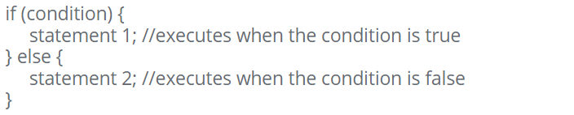

Example:



**NOTE:**

We can write the if-else statement using the shorthand method, that is using ternary operators ( ? : ).

Example:

